AIMS5740 Final Project

Topic 1 — Data Selection + RL for LLMs (Math / STEM)

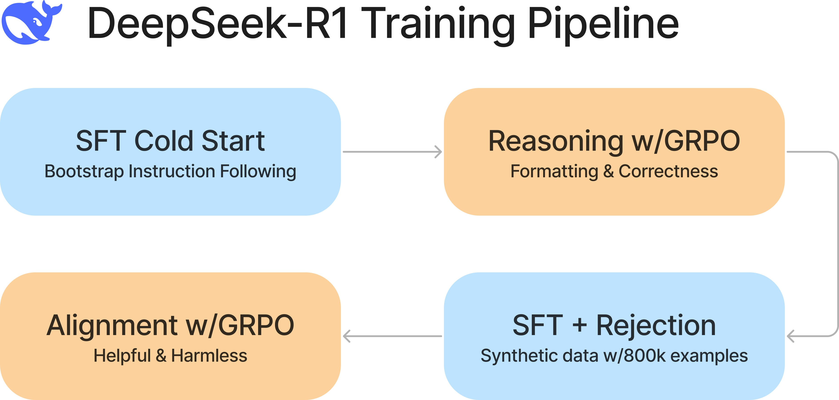

Background
LLMs often underperform on math and STEM reasoning not due to lack of capacity, but because: training data is noisy or misaligned,
SFT optimizes imitation rather than correctness, reasoning errors compound across steps.
Recent work shows that data curation + RL-style post-training can significantly improve reasoning accuracy.

Related Work
You are encouraged to cite and relate your project to:
MetaMath / MetaMathQA https://meta-math.github.io/
(large-scale math data curation and training signals) GRPO Group Relative Policy Optimization)
https://huggingface.co/learn/cookbook/en/fine_tuning_llm_grpo_trl
(practical RL recipe for reasoning-oriented post-training) Verifier-based RL for math reasoning https://arxiv.org/abs/2110.14168

(training verifiers to guide math problem solving)

Suggested Base Models (similar to hm1)
Choose one:
Qwen2.5-0.5B
Llama-3.2-1B-Instruct

Smaller models are preferred for RL due to stability and iteration speed.

Pipeline Overview

Stage A — Data Selection
Choose at least one: https://huggingface.co/datasets/zwhe99/DeepMath-103K SynthLabsAI/Big-Math-RL Verified
STEM subset from instruction data (verifiable) Apply explicit filtering rules, e.g.:
remove ambiguous problems, enforce clean final-answer formats, length and difficulty control.

Stage B — Supervised Fine-Tuning (SFT)
Framework: llama-factory
Output: Base vs SFT model comparison (loss, evaluation accuracy)

Stage C — Reinforcement Learning
Choose:
Verifier-based reward (exact match)
Reward design must include ≥2 components, e.g.: correctness reward,
format or reasoning-structure reward.

Evaluation Benchmarks
Use or other standard evaluation pipeline, or the official evaluation code:
lm-eval-harness
HuggingFaceH4/MATH 500 https://huggingface.co/datasets/openai/gsm8k https://huggingface.co/datasets/TIGER Lab/TheoremQA

Analysis Expectations
Does RL improve correctness but hurt general QA? Sensitivity to data filtering?

Deliverables (All Topics)
Code
training scripts, evaluation scripts, reproducible README.
Final Report 6 8 pages) background + related work, method & algorithm overview, experiments,
analysis & limitations.
Presentation (specific info to be announced later)

Project Takeaways
After completing this project, you should be able to: design an end-to-end training + evaluation pipeline, understand why alignment methods work or fail,
reason about failure modes beyond leaderboard scores,
operate under realistic compute constraints.

Flexibility & Grading Policy (Important)
The pipeline stages, analysis items, suggested base models, training frameworks, and benchmark list above are recommendations for reference, not strict requirements. You are free to modify the pipeline design (e.g., different data selection strategy, SFT/RL framework, reward definition, model choice, or evaluation suite) as long as your choices are well-motivated, clearly documented, and lead to meaningful experimental evidence.
We will evaluate your project primarily by overall quality, including: clarity of problem setup and motivation,
soundness of methodology and reward design (for RL), rigor and completeness of experiments,
quality of analysis (ablations, failure modes, trade-offs), reproducibility (clean code, configs, clear reporting),
not by strict adherence to the exact models / datasets / tools / benchmarks listed above.

